**Experiment 6**

**Lab Book:**



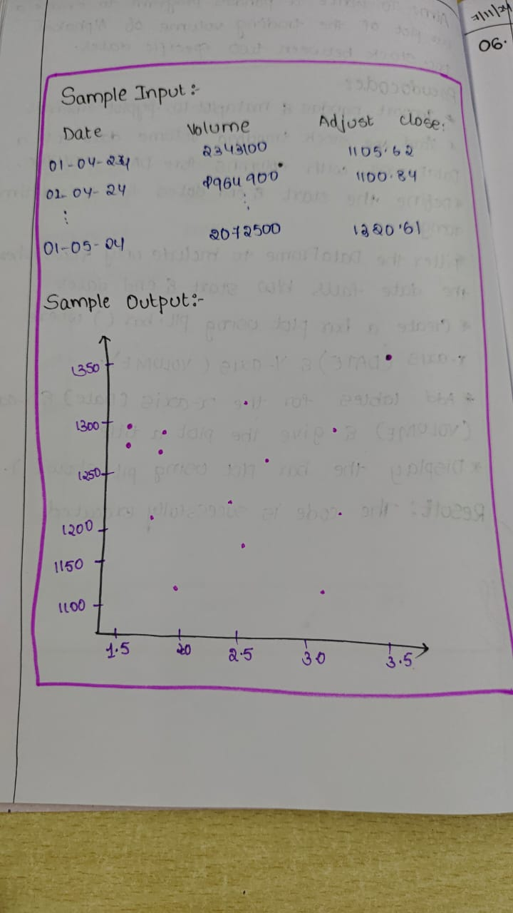

**Code:**

import pandas as pd

import matplotlib.pyplot as plt

data = {

    'Date': [

        '01-04-2020', '02-04-2020', '03-04-2020', '06-04-2020', '07-04-2020',

        '08-04-2020', '09-04-2020', '13-04-2020', '15-04-2020', '16-04-2020',

        '17-04-2020', '20-04-2020', '21-04-2020', '22-04-2020', '23-04-2020',

        '24-04-2020', '27-04-2020', '28-04-2020', '29-04-2020', '30-04-2020',

        '01-05-2020'

    ],

    'Volume': [

        2343100, 1964900, 2314300, 2664700, 2877300, 2787400, 2765700, 2573000,

        1671700, 1517800, 1955000, 1593000, 1684300, 1564600, 1600700, 1641600,

        2168800, 1613500, 3793600, 2695400, 2072500

    ],

    'Adj Close': [

        1105.62, 1100.84, 1097.88, 1186.92, 1186.51, 1110.21, 1211.45, 1217.35,

        1262.47, 1278.45, 1266.21, 1261.84, 1266.24, 1278.31, 1273.38, 1275.51,

        1288.43, 1249.68, 1341.48, 1278.06, 1320.61

    ]

}

df = pd.DataFrame(data)

df['Date'] = pd.to_datetime(df['Date'], format='%d-%m-%Y')

start_date = '2020-04-01'

end_date = '2020-05-01'

filtered_df = df[(df['Date'] >= start_date) & (df['Date'] <= end_date)]

plt.figure(figsize=(10, 6))

plt.scatter(filtered_df['Volume'], filtered_df['Adj Close'], color='blue', alpha=0.5)

plt.title('Trading Volume vs. Adjusted Closing Price (Alphabet Inc.)')

plt.xlabel('Volume')

plt.ylabel('Adjusted Close Price')

plt.grid(True)

plt.show()

**Sample Output**

